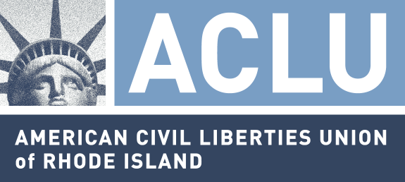
128 DORRANCE STREET, SUITE 220
PROVIDENCE, RI 02903
401.831.7171 (t)
401.831.7175 (f)
www.riaclu.org

TESTIMONY IN SUPPORT OF 15-S 276,
RELATING TO FAIR EMPLOYMENT PRACTICES
April 1, 2015

The ACLU of Rhode Island strongly supports this bill, which would ensure that pregnant women in the workplace receive the reasonable accommodations that they should be entitled to.

Discrimination on the basis of pregnancy has been illegal under federal law since 1978, but across the country pregnant and breastfeeding women have been denied employment, forced to go on unpaid leave, or otherwise discriminated against solely because of their pregnancy or breastfeeding status. Some pregnant women have found themselves in the untenable position of having to decide between following the instructions of their doctor or adhering to the dictates of their employer.

These situations have arisen because, until last week, some courts had interpreted the federal pregnancy anti-discrimination law to mean that while a women could not be directly fired for being pregnant, she could be fired for needing a reasonable accommodation in order to safely work while pregnant, even when the employer has made similar accommodations available to injured employees or workers with disabilities. These accommodations can include such things as a temporary light-duty assignment, obtaining added restroom breaks, carrying a water bottle while working, or other minor accommodations often provided other employees. Nationally, the ACLU and others have represented a number of women across the country – ranging from police officers and UPS workers to teachers and healthcare workers – who have been unfairly penalized because of their pregnancy status by employers who have refused to make reasonable accommodations in these ways.

As committee members are probably aware, the U.S. Supreme Court issued an important decision just last week interpreting the federal Pregnancy Discrimination Act to provide some protection to pregnant women on the issues. However, for at least two reasons, that decision provides more, not less, impetus for this committee to act. First, it is critical to ensure that our state Fair Employment Practices Act provides at least the minimal protections that the Court has interpreted the federal law to cover. Absent passage of this bill, employers could argue that the state law is less protective of pregnant women’s rights than the federal law.

More importantly, passage of the law would provide clear guidance to employers as to what they can and cannot do. Most small employers do not have attorneys on staff to help them parse the language of Supreme Court decisions. By placing these protections specifically in statute, employers will have clear guidance on what their rights and the rights of their employees are in this context. Indeed, over the past few decades, Rhode Island has many times amended its Fair Employment Practices Act in response to court decisions at the national level that have interpreted similar federal laws. The state would be continuing in that tradition by passing this bill to make clear what protections FEPA provides to pregnant women.

Because passage of this legislation will promote both healthy families and a healthy workforce, and will help employers and employees be aware of their rights, the ACLU strongly recommends approval of S-276.

